[**Griffiths**](https://docs.google.com/document/d/1Hmlp39B4ErLKe3b8TO1vQpZW5r9T0sCYiy9b404jAr8/edit?usp=sharing) **et al,**

Table 1. Environmental data from CTD drops in choked pass on June 30th 2015.

|  |  |  |  |  |  |  |  |  |  |  |  |  |  |  |
| --- | --- | --- | --- | --- | --- | --- | --- | --- | --- | --- | --- | --- | --- | --- |
| CTD Depth (m) | Conductivity (mS/cm) | | Temperature (°C) | | Dissolved oxygen (mg/L) | | Chla  (ug/L) | | Nitrate + Nitrite (uM) | | Phosphate (ug/L) | | Salinity (ppt) | |
|  | |  | | ***Outside Bed Bottom (outside on ocean side)***  (51.67147, -128.12367) | | | |  | |  | |  | |  |
| 9.49 | | 34.95 | | 10.78 | | 7.94 | | 0.5170 | | 11.116 | | 1.076 | | 31.13 |
|  | |  | | ***Interior Bed Bottom (centre of meadow)***  (51.6782,-128.1147) | | | |  | |  | |  | |  |
| 6.47 | | 3*3.85* | | 1*0.28* | | 7.37 | | 0.0788 | | 1.5194 | | 0.3477 | | 30.46 |
|  | |  | | ***Edge Bottom (Wolf site)***  (51.66825,-128.11855) | | | |  | |  | |  | |  |
| 4.57 | | 35.02 | | 11.54 | | 9.72 | | 0.0449 | | 5.884 | | 0.6839 | | 30.56 |

**Table 2** Sample sizes for the experiments and treatment levels in the reciprocal transplant experiment. Biomass could only be measured on shoots following transplant but all shoots were swabbed before and after to determine microbial communities. Edge and Interior refer to high and low *Smithora* load locations used for the transplant experiment (Figure 1C), as well as their position in the seagrass meadow.

**Treatments Shoot-level Metrics Sample Size**

Edge Experiment Pre-transplant Microbial community 3

Interior Experiment Pre-transplant Microbial community 3

Edge Control Pre-transplant Microbial community 5

Interior Control Pre-transplant Microbial community 4

Edge Experiment Post-transplant Microbial community, Smithora biomass 3

Interior Experiment Post-transplant Microbial community, Smithora biomass 3

Edge Control Post-transplant Microbial community, Smithora biomass 5

Interior Control Post-transplant Microbial community, Smithora biomass 4

Edge Ambient Microbial community, Smithora biomass 2

Interior Ambient Microbial community, Smithora biomass 2

|  |  |  |  |  |
| --- | --- | --- | --- | --- |
| **Variable type** | **Variable** | **Treatment** | **Sample size – pre expt** | **Sample size – post expt** |
| Experimental response | Microbiota | Edge/Expt | 3 | 3 |
| Experimental response | Microbiota | Int/Expt | 3 | 3 |
| Experimental response | Microbiota | Edge/Control | 5 | 5 |
| Experimental response | Microbiota | Int/Control | 4 | 4 |
| Experimental response | *S. naiadum* biomass | Edge/Expt | NA | 3 |
| Experimental response | *S. naiadum* biomass | Int/Expt | NA | 3 |
| Experimental response | *S. naiadum* biomass | Edge/Control | NA | 5 |
| Experimental response | *S. naiadum* biomass | Int/Control | NA | 4 |
| Environmental attribute | Microbiota | ambient | 2 | ? |
| Environmental attribute | Microbiota | ambient | 2 | ? |
| Environmental attribute | Grazer density and diversity | All? Or ambient? | 6? | 6? |
| Environmental attribute | Leaf with, length and biomass | All? |  |  |

**FIGURE 1**. A) Study site at Calvert Island BC. B) Choked pass, site of experimental transplants and surveys of *Smithora* *naiadum* and *Zostera marina.* Eight sites in the meadow were surveyed using 40 m transects. C) *Smithora* biomass / *Zostera* biomass at edge (OS,IS,AL,WF) vs interior (ID,IT,IS,IA) sites; differences were significant (P < 0.001). The site of the reciprocal transplant is proximate to WF & IA (lower left).

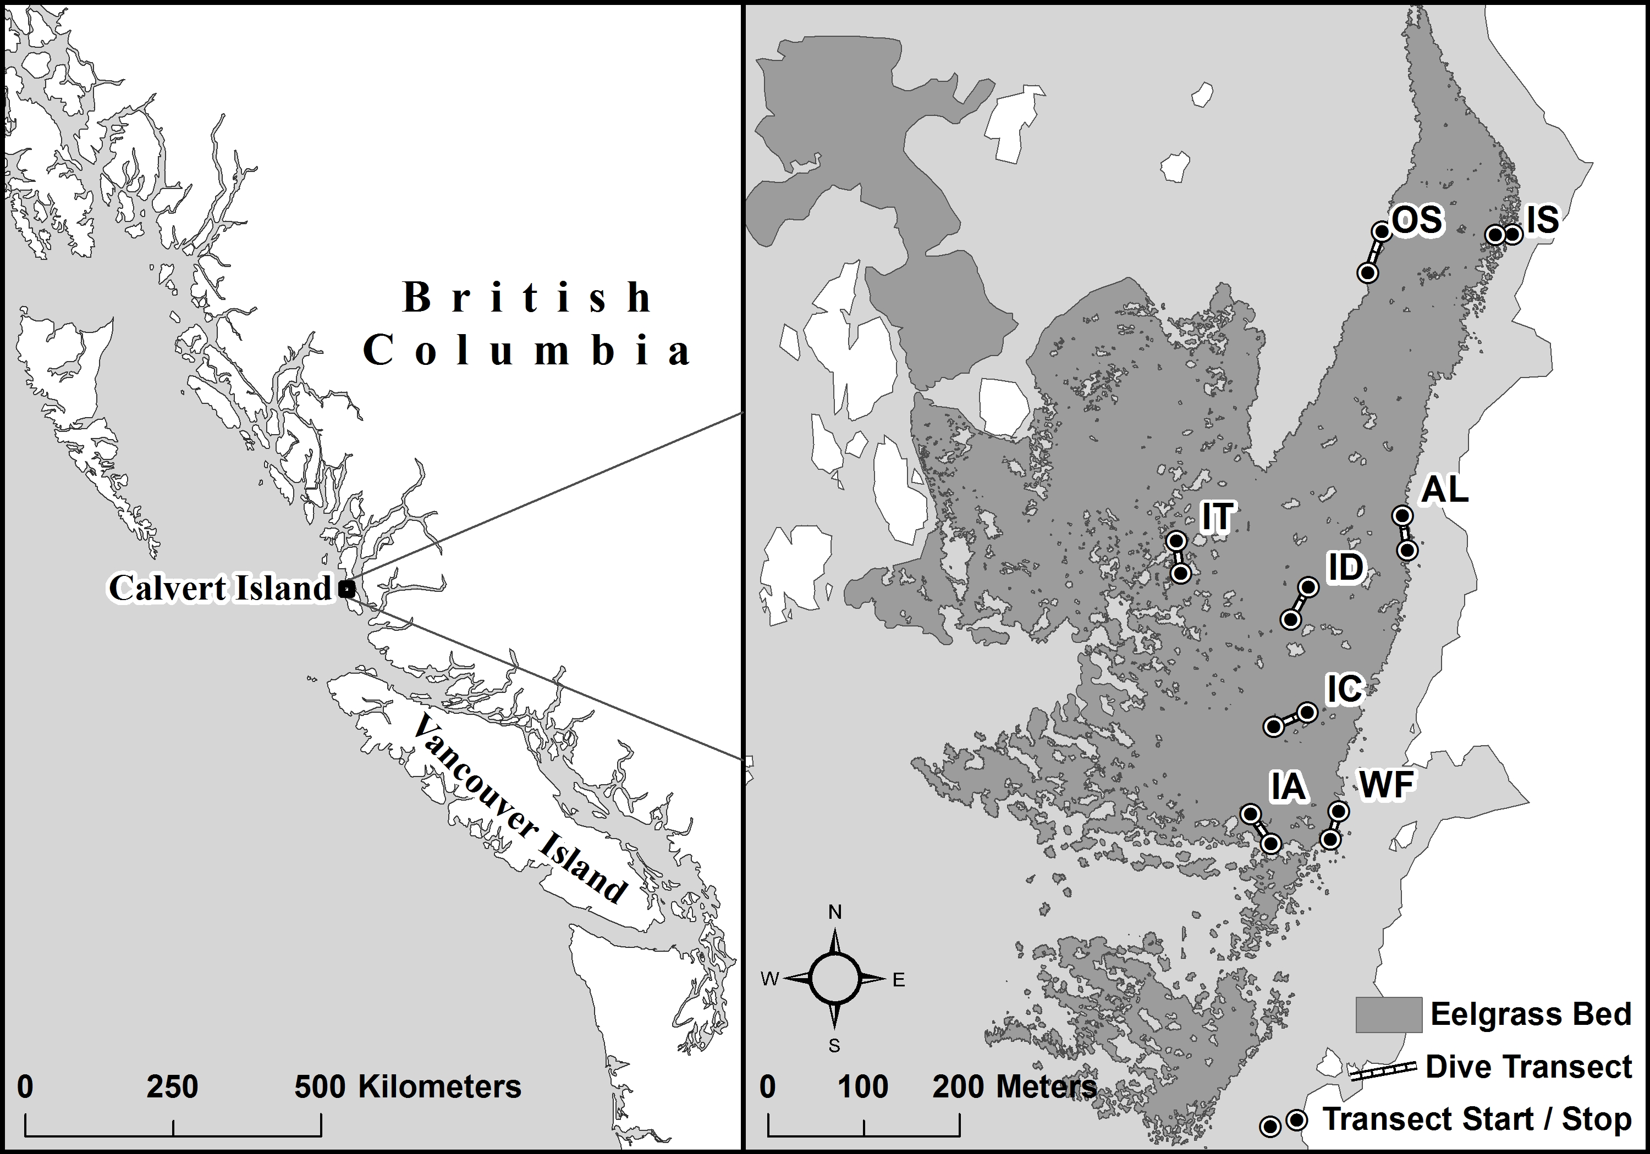

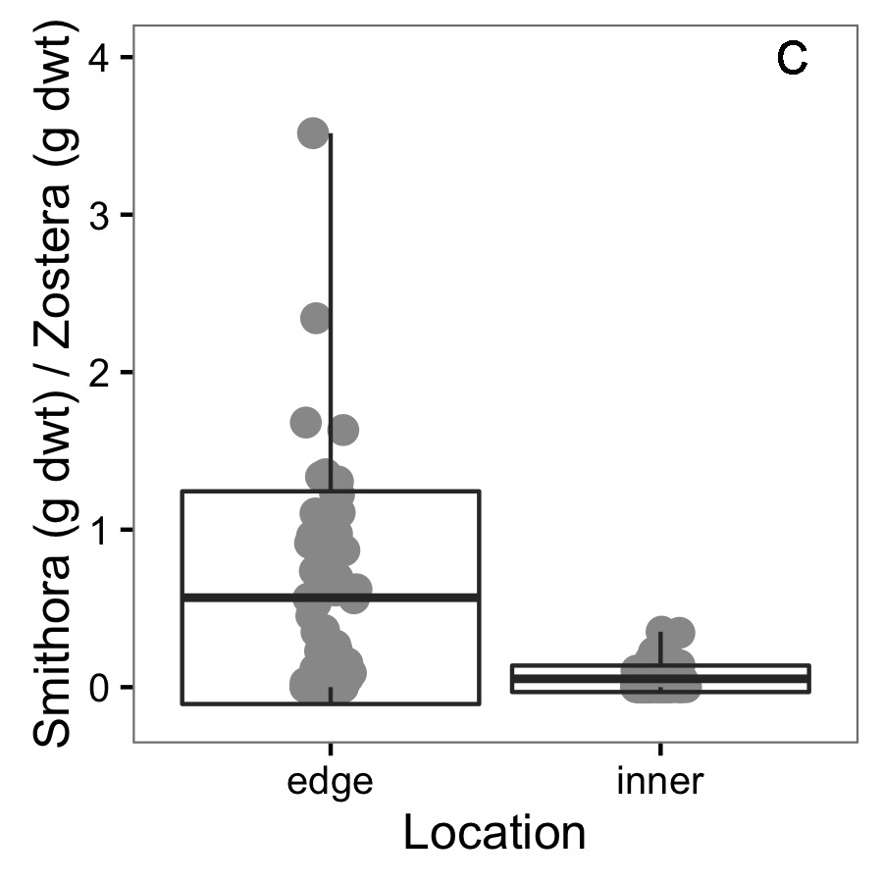

**Figure 2.** Conditions at the two experimental transplant sites (Edge ‘WF’ and Interior ‘IA’) before the experiment in June 2015. For six replicate samples of 0.0625 m2 of seagrass meadow, A) *Z. marina* dry weight of above ground biomass, B) *Smithora* dry weight biomass (per *Z. marina* shoot biomass) C) grazer abundance over experimental time frame (June before, July during) and D) seagrass surface bacterial grouped by Smithora = Edge, No Smithora = Interior. See appendix for grazer composition comparison.

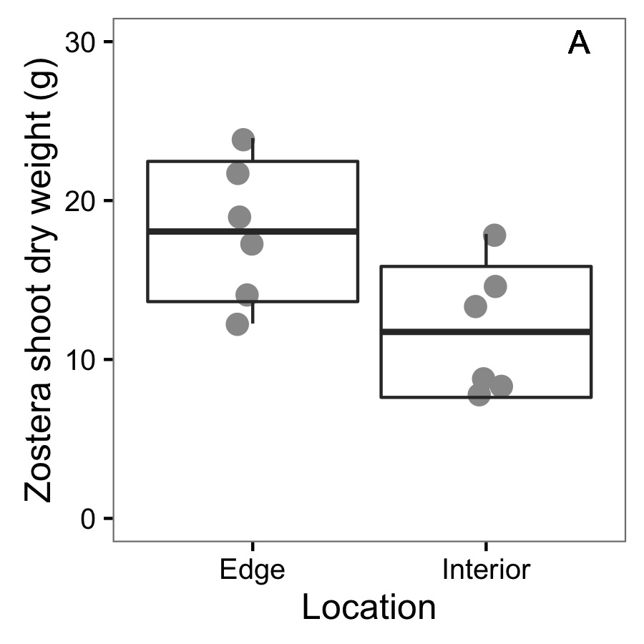 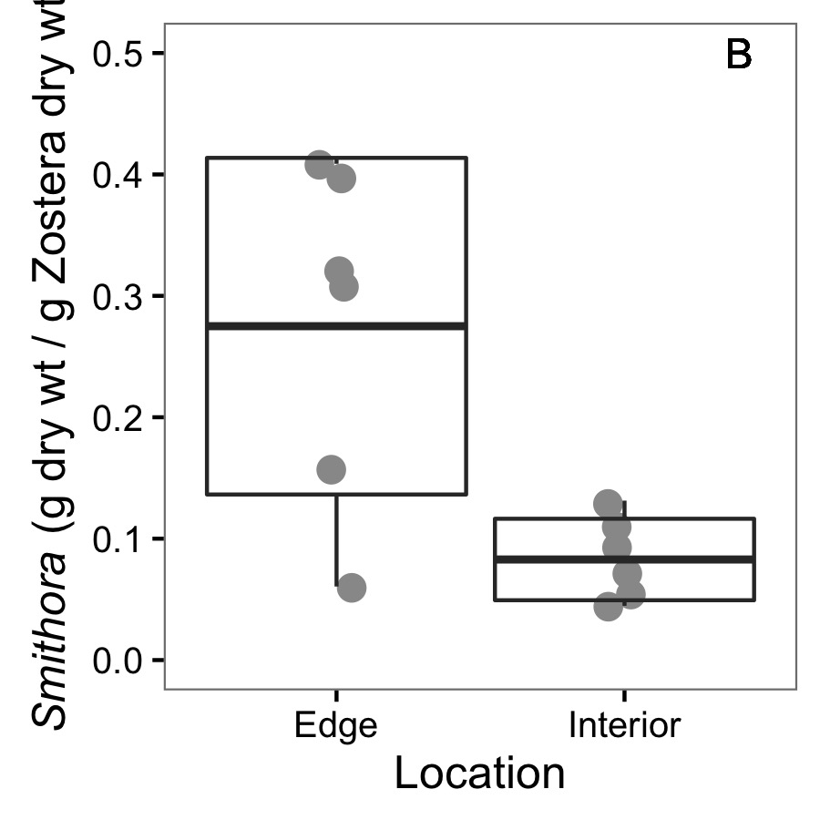

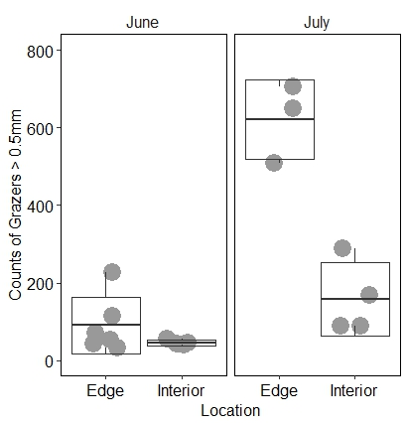

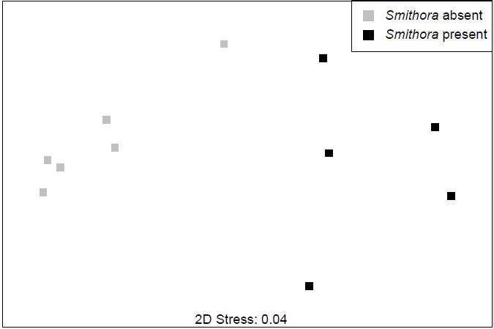

D

**Figure 3**. Final *Smithora* abundance (g / g *Zostera* dry wt) for experimental and control shoots in the reciprocal transplant experiment. Box indicates mean and 1 standard deviation.

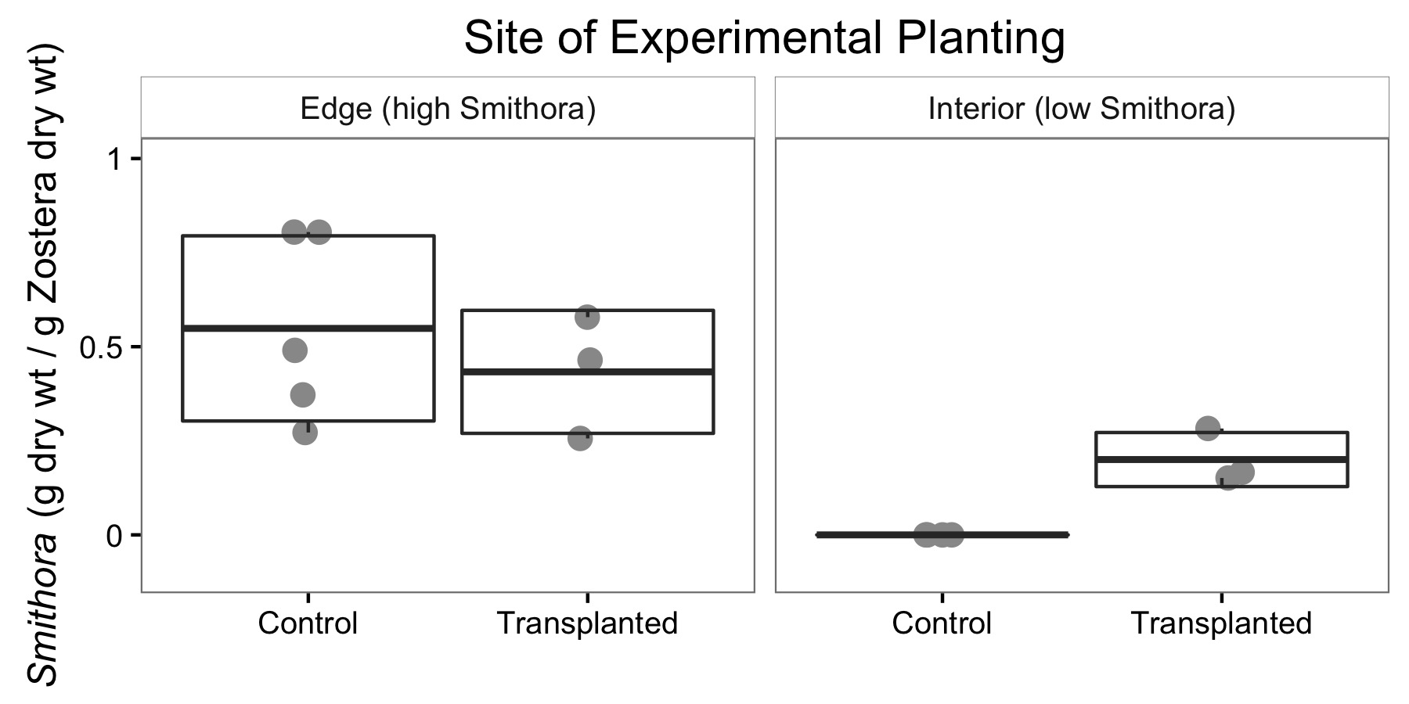

**Figure 4**. Bacterial assemblages after transplant with treatments indicated.

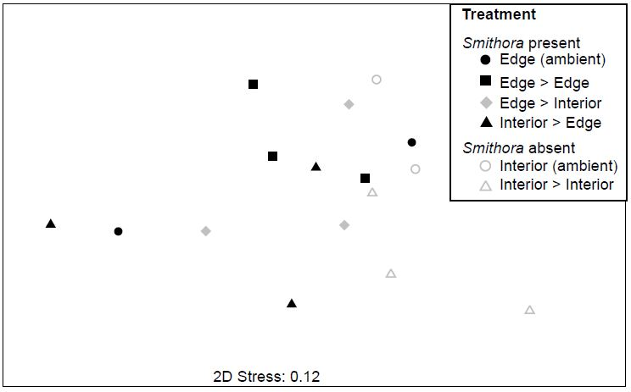

**APPENDIX:**

Figure A1: *Zostera marina* shoot density at transplant sites.

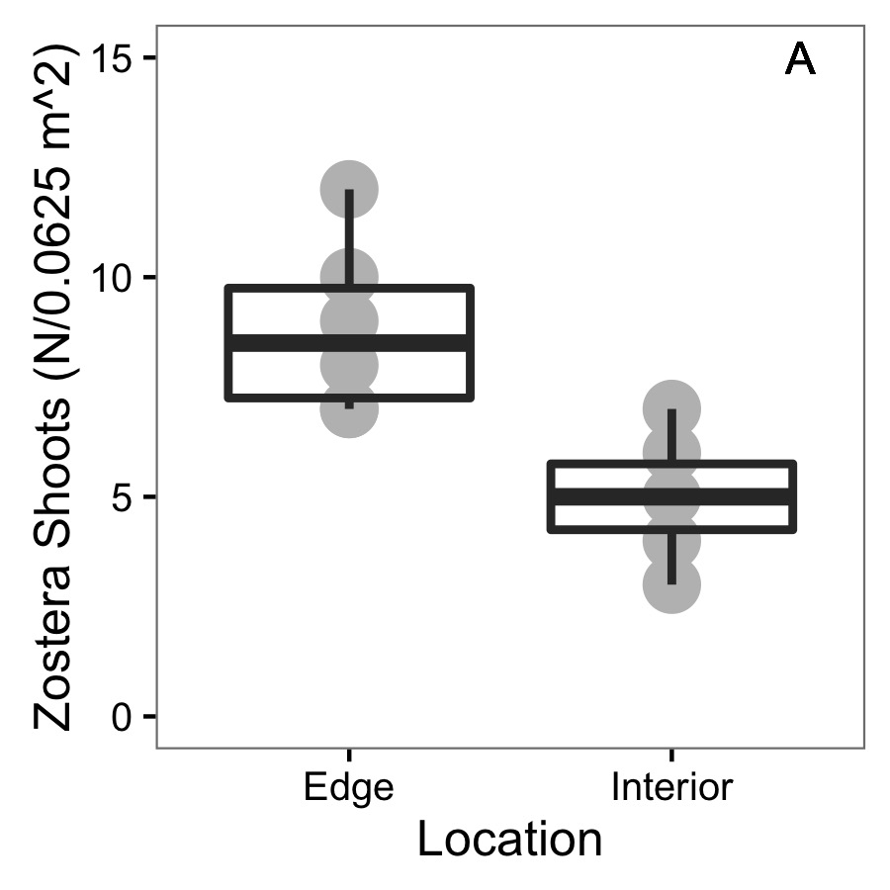

Figure A2: NMDS for grazer assemblages at transplant sites before experiment. Red hull is interior and grey hull is edge. Stress is 0.2873149.

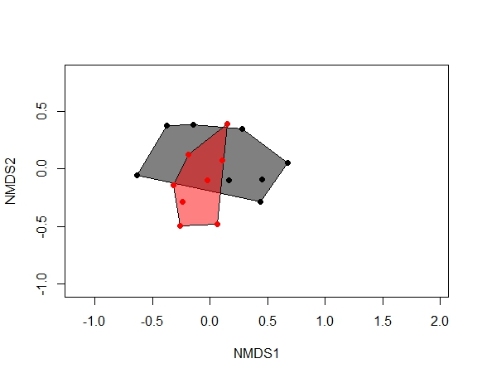

Figure A3: NMDS for grazer assemblages on non-experimental ambient shoots at transplant sites before and after experiment. Red hull is June and grey hull is July. Stress is 0.2873149.

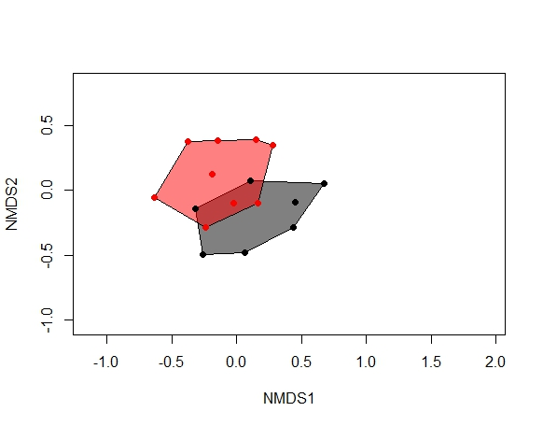

Figure A4. Bacterial composition of transplanted shoots plots grouped to order.

